**Project Design Phase-II**

**Solution Requirements (Functional & Non-functional)**

|  |  |
| --- | --- |
| Date | 01 Nov 2023 |
| Team ID | NM2023TMID05793 |
| Project Name | Create an email campaign in mail chimp |

**1.Functional Requirements:**

Following are the functional requirements of the proposed solution.

|  |  |  |
| --- | --- | --- |
| **FR No.** | **Functional Requirement**  **(Epic)** | **Sub Requirement (Story / Sub-Task)** |
| FR-1 | **User Registration and Management:** | * Allow users to sign up for the newsletter through a subscription form on your website. * Implement double opt-in functionality for confirmation of subscriptions. * Provide a user management system to handle unsubscribes, preferences, and profile updates. |
| FR-2 | **Newsletter Design and Content:** | * Create and customize email templates to match your brand's design. * Support various content types, including text, images, videos, links, and social media integration. * Offer a user-friendly editor for composing newsletters   without coding knowledge. |
| FR-3 | **Subscriber Segmentation:** | * Enable segmentation based on subscriber data (e.g., location, demographics, purchase history). * Support dynamic content that changes based on subscriber segments. |
| FR-4 | **Scheduling and Automation:** | * Schedule email delivery at optimal times for your target audience. * Implement automation features for welcome emails, drip campaigns, and event-triggered emails. |
| FR-5 | **Personalization:** | * Allow for personalization of emails, such as using subscribers' names and custom content. * Implement merge tags for dynamic insertion of subscriber data. |
| FR-6 | **Tracking and Analytics:** | * Provide detailed analytics on email performance, including open rates, click-through rates, and conversion rates. * Integrate with Google Analytics for tracking website traffic generated from email campaigns. |

**Non-functional Requirements:**

Following are the non-functional requirements of the proposed solution.

|  |  |  |
| --- | --- | --- |
| **FR No.** | **Non-Functional Requirement** | **Description** |
| NFR-1 | **Performance:** | * Response Time: The email newsletter should load quickly for subscribers, both on desktop and mobile devices. * Scalability: Mailchimp should be able to handle a growing subscriber base without a significant decrease in performance. |
| NFR-2 | **Reliability:** | * Uptime: Mailchimp should have a high level of uptime to ensure that newsletters are delivered consistently and without interruptions. * Data Backup and Recovery: Regular data backups and a reliable recovery plan should be in place to protect against data loss. |
| NFR-3 | **Security:** | * Data Encryption: Ensure that data transmitted between Mailchimp and your subscribers is encrypted to protect sensitive information. * Authentication: Implement security measures to prevent unauthorized access to your Mailchimp account and subscriber data. |
| NFR-4 | **Compliance:** | * Email Regulations: Ensure that the email newsletters comply with email marketing regulations and laws, such as CAN-SPAM or GDPR. * Privacy: Respect the privacy of subscribers by providing opt-in and opt-out options, and clearly explaining your data usage and privacy policies. |
| NFR-5 | **User Experience:** | * Accessibility: The email newsletters should be accessible to all users, including those with disabilities. * Responsive Design: Ensure that newsletters are responsive and look good on various devices and email clients. |
| NFR-6 | **Scalability:** | * List Management: Mailchimp should be able to handle and manage large subscriber lists efficiently. * Integration: Ensure Mailchimp can integrate with other tools and platforms as your needs evolve. |
| NFR-7 | **Deliverability:** | * Inbox Placement: Aim for high inbox placement rates to ensure that newsletters reach subscribers' primary inboxes and avoid being marked as spam. * Anti-Spam Measures: Implement best practices to prevent newsletters from being marked as spam. |

**2.REQUIREMENT ANALYSIS (FLOW CHART):**

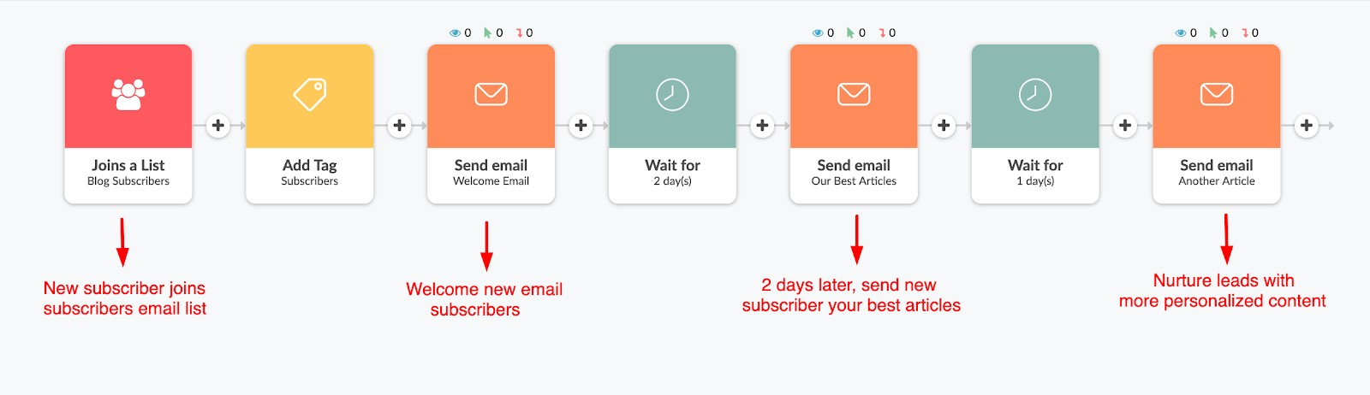

**3.TECHNICAL**

**ARCHITECTURE**

**:**

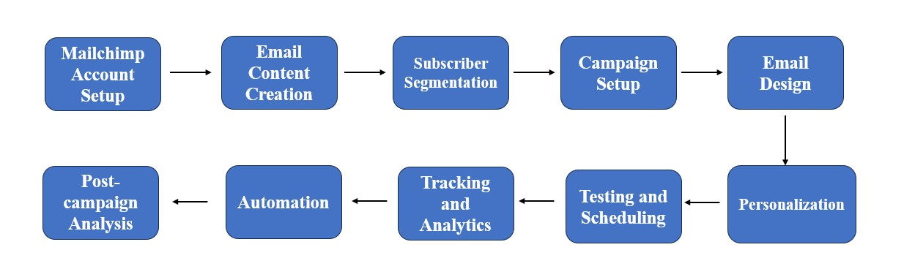

**4.OPEN-SOURCE FRAMEWORKS:**

**Sign up and log in:** Create a Mailchimp account if you don't have one, or log in to your existing account.

**Create an Audience:** Before you can send email campaigns, you need to create an audience, which is essentially your email list. Import your contacts or set up a signup form on your website to gather subscribers.

**Create a Campaign:**

* Click on "Campaigns" in the top navigation menu.
* Choose "Email" to create an email campaign.
* Select the audience you want to send the campaign to.

**Choose a Campaign Type:**

* "Regular" for a standard email campaign.
* "Automated" for sending automated emails triggered by specific events or actions.
* "RSS-Driven" for campaigns based on your blog or website's RSS feed.

**Design Your Email:**

* Use Mailchimp's email editor to create your email content.
* You can choose from various templates, customize them, and add your branding elements.
* **Set Recipient Information:**
* Add a subject line, sender name, and sender email address. ❖ Configure tracking options like open and click tracking.

**Schedule or Send Now:**

Choose to send the email immediately or schedule it for a later time.

**Review and Confirm:**

* Review your campaign, and make sure everything looks good.
* Confirm and send the email campaign.

**Track and Analyse:**

Monitor the performance of your email campaign, including open rates, clickthrough rates, and conversion data. Use Mailchimp's reporting and analytics tools to gain insights into the effectiveness of your campaign.

**5.THIRD PARTY API**

**Mailchimp API:**

Mailchimp provides its own API, allowing you to interact with your email campaigns, subscribers, and other data programmatically. You can use it to integrate Mailchimp with your own applications or services.

**Zapier:**

Zapier is a popular automation platform that allows you to connect various apps and services, including Mailchimp, with other software. You can create automated workflows that trigger email campaigns based on specific events or data changes in other applications.

**Integromat:**

Similar to Zapier, Integromat is an automation platform that enables you to connect different apps and services. It supports Mailchimp and can help you automate email campaigns based on triggers from other apps.

**SendinBlue:**

SendinBlue is an email marketing platform with its own API and integrations. It provides email campaign management features and can be used as an alternative to Mailchimp for your email campaigns.

**HubSpot:**

HubSpot offers marketing automation and CRM tools with integrations for email campaigns. You can create and manage email campaigns within HubSpot, which also supports various third-party integrations.

**ActiveCampaign**:

ActiveCampaign is another email marketing and marketing automation platform with a comprehensive API. It allows you to create and manage email campaigns and integrate with other applications.

**6.CLOUD DEPLOYMENT:**

**Sign Up and Set Up Mailchimp:**

If you haven't already, sign up for a Mailchimp account else Log in to your Mailchimp account.

**Create an Audience:**

In Mailchimp, you need to have an audience (your email list) to send your campaign to. Create a new audience or use an existing one.

**Design Your Email:**

Design the email campaign you want to send using Mailchimp's email builder. You can choose from various templates or create your own.

**Add Content:**

Add content to your email, including text, images, and any other elements you want to include.

**Set Up Tracking and Analytics:**

Configure tracking and analytics settings to monitor the performance of your campaign. You can track open rates, click-through rates, and more.

**Schedule or Send Now:**

Decide whether you want to send your campaign immediately or schedule it for a specific date and time. Now, when it comes to deploying this campaign in the cloud, you have a few options:

**Option 1:** Use Mailchimp's Built-in Sending Service:

Mailchimp itself provides the infrastructure to send your email campaigns, so you don't need to deploy it to the cloud. This is the simplest option, and it's suitable for most users.

**Option 2:** Deploy a Mailchimp Integration:

You can deploy a Mailchimp integration or connector in the cloud to automate and enhance your email marketing. These integrations can sync data between Mailchimp and other systems you might be using, such as a CRM or e-commerce platform.

**Option 3:** Custom Deployment:

If you have specific requirements that go beyond Mailchimp's built-in features or integrations, you can build a custom solution using cloud services like AWS, Google Cloud, or Azure. Here's a high-level overview of what a custom deployment might involve:

1. **Data Syncing:** You'll need to set up processes to sync your audience data with Mailchimp's API or integrate it directly with your custom solution.
2. **Email Sending Infrastructure:** You can use cloud-based email sending services or SMTP relay services to send emails at scale securely.
3. **Campaign Management:** Create a system to manage your email campaigns, including scheduling and tracking, using cloud databases and application services.
4. **Design and Content Storage:** Store your email templates and campaign content in a cloud-based storage solution like Amazon S3 or Google Cloud Storage.
5. **Analytics:** Set up analytics and tracking using cloud-based services like Google Analytics, AWS Lambda, or Azure Functions.
6. **Security and Compliance:** Ensure that your custom solution complies with email marketing regulations, including GDPR and CAN-SPAM Act.
7. **Monitoring and Scaling:** Implement monitoring and scaling solutions to handle increases in email traffic and ensure high deliverability rates.